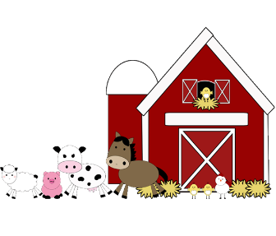R One Farms

Field Trip

**Permission Slip**

Due September 16th, 2019

Kindergarten and 1st grade will be going to the R One Farms,

Wednesday, September 18th.

I give my permission for: ______________________

to attend the Field Trip to the R One Farms.

Parent signature: __________________

 - - - - - - - - - - - - - - - - - - - - - - - - - - - - - - - - - - - -

We will be learning about different animals, how to take care of them, and about the tools on a farm. We will be leaving school around 8:30 and returning to school before 10.

Please make sure you child has:

• Cochise Shirt

• Long pants/ jeans

• Good walking shoes

• Water bottle

• Sunscreen